Recursive Problems

Recursion that are fine as iterative
factorial
fibonacci
reverse a word
Factors

Straight-Forward Recursion
queens 8
gcd
towers of Hanoi
Pascal's Triangle
convert to binary
Flood Fill

Fractal Tree
Sierpinski's Triangle
Mandelbrot set

Contest Style Recursion
Shortest Path
Golf Club
Santa's Magic Sack
Truckin'
Water Park
Golf
In golf certain clubs will drive a certain length. Prompt the user for the length of a hole, the number of clubs in the bag and the length each club will carry the ball.
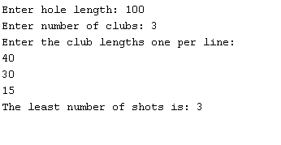
Version 1: Assuming that the club lengths are given in descending order and that each subsequent club is less than half the previous club length, print out the number of shots it takes to get to the whole
Version 2: Making none of the above assumptions, print out the number of shots it takes to get to the whole and indicate when it’s impossible to get in the whole.
Version 3: Indicate how many shots of each club were taken.

- Bit Patterns
Write a program that repeatedly reads two numbers n and k and prints all bit patterns of length n with k ones in descending order (when the bit patterns are considered as binary numbers). You may assume that 30 >= n > 0, 8 >= k > 0, and n >= k. The first number in the input gives the number of pairs n and k. The numbers n and k are separated by a single space. Leading zeroes in a bit pattern should be included. See the example below.
Sample input:
3
2 1
2 0
4 2
Sample output:
The bit patterns are
10
01

The bit patterns are
00

The bit patterns are
1100
1010
1001
0110
0101
0011

